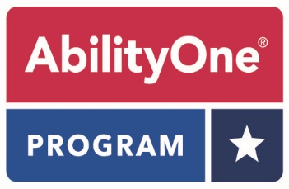

Federal Customer
“Essentially the Same” (ETS) Waiver Request

The AbilityOne Program generates employment opportunities for individuals who are blind or have another significant disability and is a mandatory source of supply per FAR 8.7. You can learn more about the AbilityOne Program by visiting www.abilityone.gov.

This form is required to submit a request to purchase a commercial ETS product in lieu of an AbilityOne product. Please fill out all required fields and e-mail the completed form to Mike Jurkowski at mjurkowski@abilityone.gov. Please include “ETS Waiver Request” in the subject line.

- Commercial ETS Product Name: ______________________________________________

- Commercial ETS Product Item Number: _____________________________________

- AbilityOne NSN: __________________________________________________________________

Please provide a detailed explanation of why the AbilityOne product will not meet your need and the commercial ETS product will based on verifiable differences in specifications. NOTE: Price and perceived performance issues are not an acceptable reason for a waiver. If you believe you are experiencing performance issues with an AbilityOne product, please provide the details in an email to mjurkowski@abilityone.gov. The issue will be addressed with the manufacturing nonprofit agency:

ETS Waiver Request -
Federal Customer
Page 2

Federal Customer Information:

Name: _________________________________________________________________________________

Agency:________________________________________________________________________________

Date: ___________________________________________________________________________________

Phone: _________________________________________________________________________________

E-Mail: _________________________________________________________________________________

